Wolf Steel

Assigned to: Natasha

Reporting Month: March 2025

# Results and Discussion

# Appendix A: SGS Tables & Graphs

## Raw Sewage Table

|  |  |  |  |
| --- | --- | --- | --- |
| Date | BOD5 | TSS | TKN |
| 09-Jan-25 | 47 | 23 | 62 |
| 05-Feb-25 | 429 | 110 | 141 |
| 05-Mar-25 | 354 | 72 | 145 |

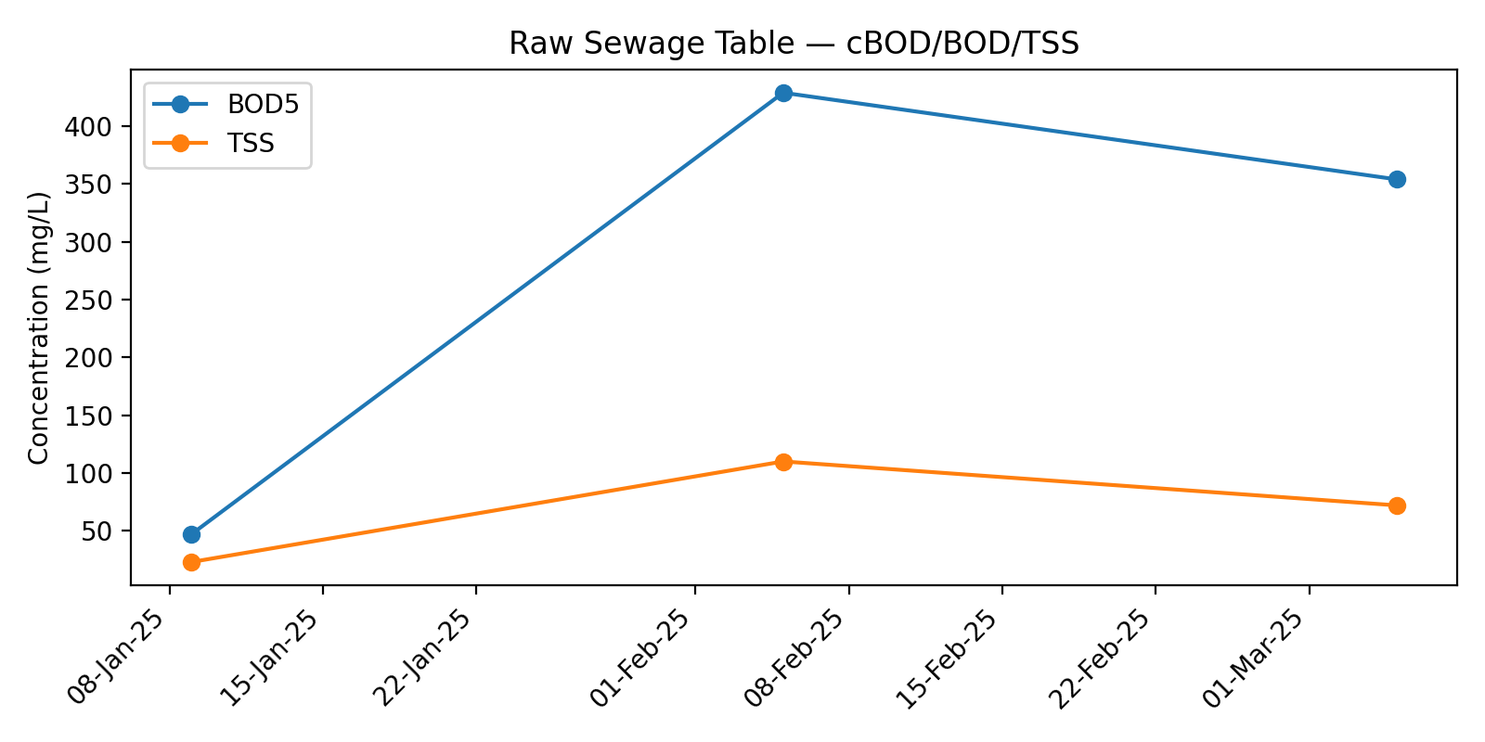

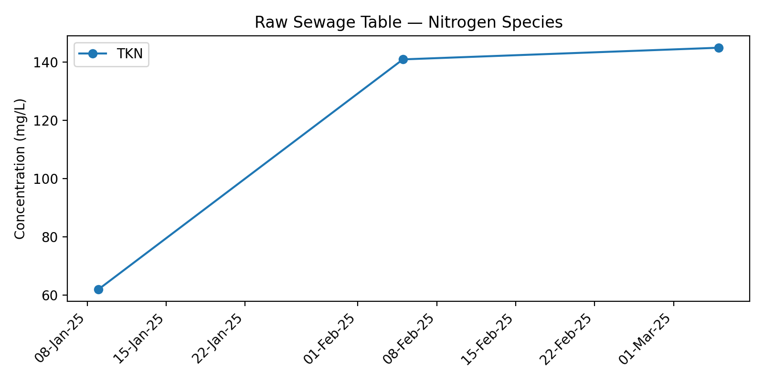

## Biofilter Effluent Table

|  |  |  |  |  |
| --- | --- | --- | --- | --- |
| Date | cBOD5 | TAN | NO3 | NO2 |
| 09-Jan-25 | 4 | 0.7 | 47.8 | 0.3 |
| 05-Feb-25 | 20 | 1 | 49 | 0.3 |
| 05-Mar-25 | 4 | 1.6 | 50.2 | 0.3 |

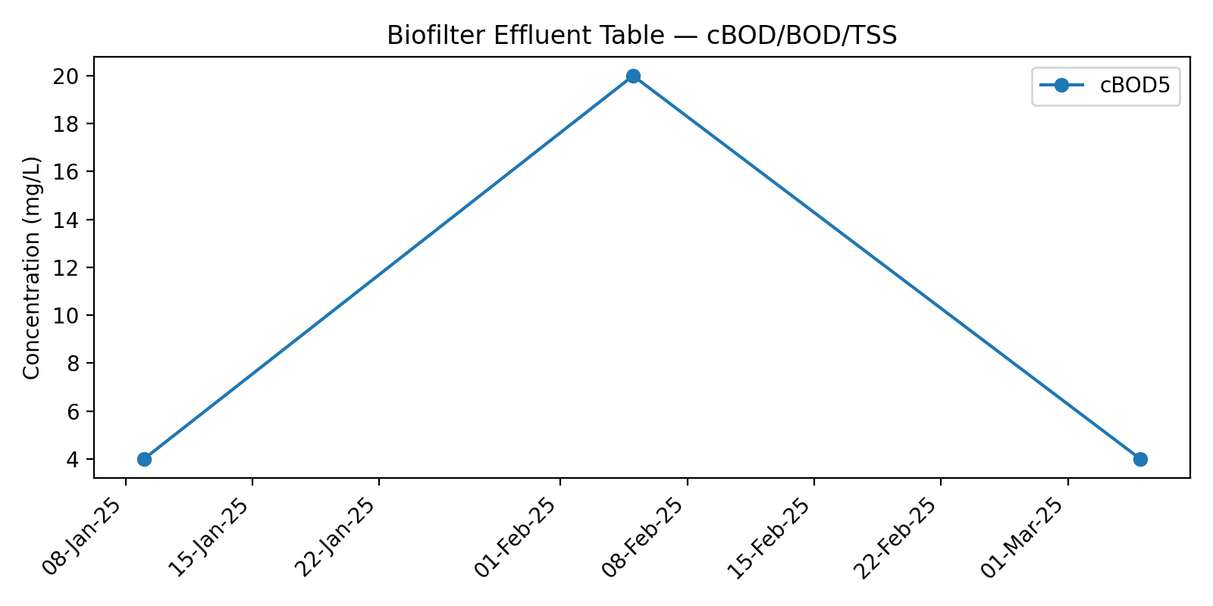

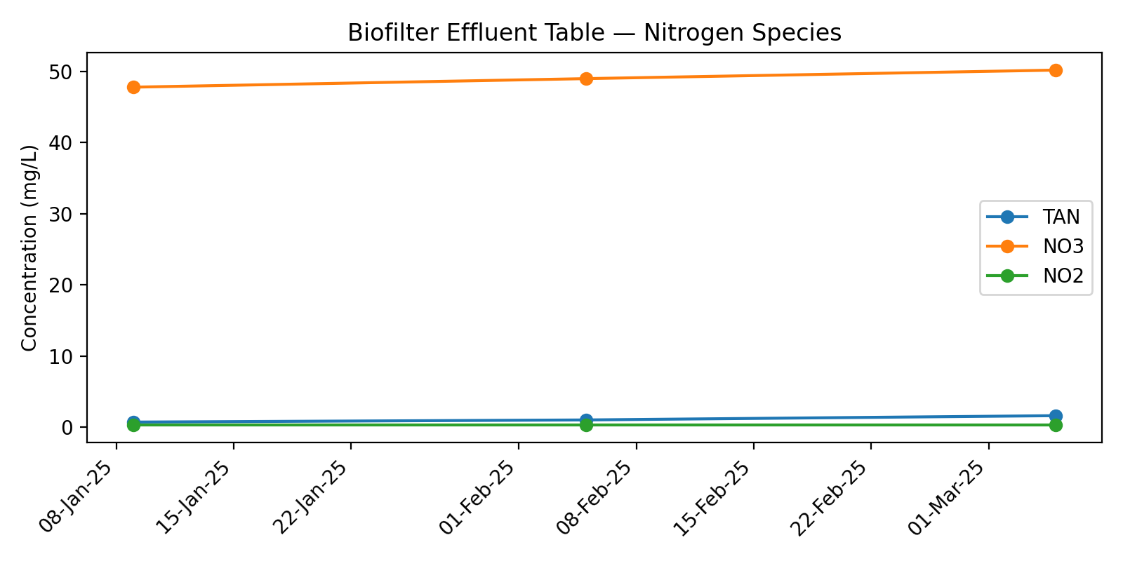

## WaterNOx-LS Effluent Table

|  |  |  |  |  |
| --- | --- | --- | --- | --- |
| Date | cBOD5 | TAN | NO3 | NO2 |
| 09-Jan-25 | 35 | 0.1 | 0.06 | 0.3 |
| 05-Feb-25 | 29 | 0.1 | 0.06 | 0.3 |
| 05-Mar-25 | 34 | 0.1 | 0.06 | 0.3 |

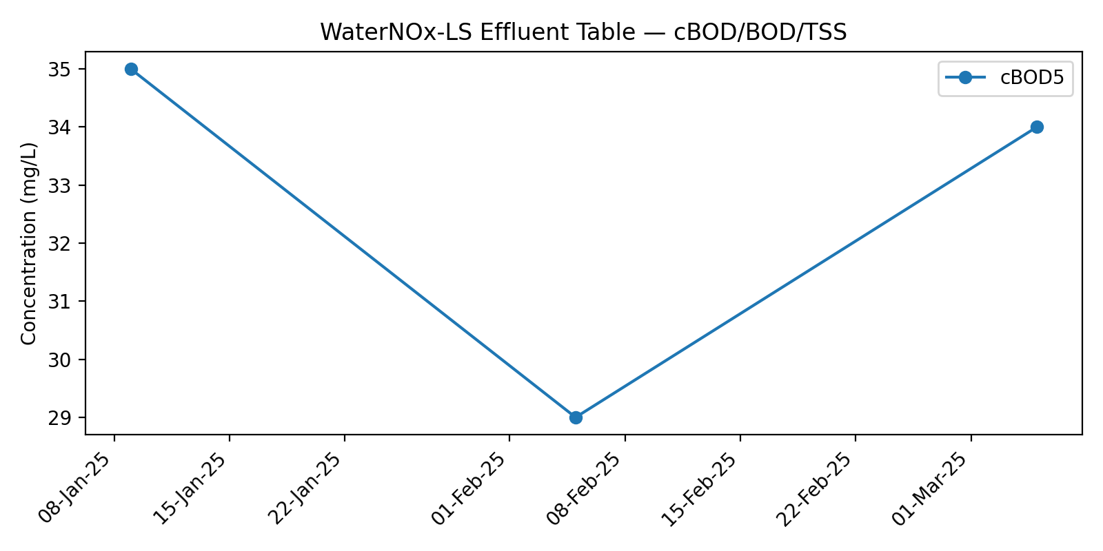

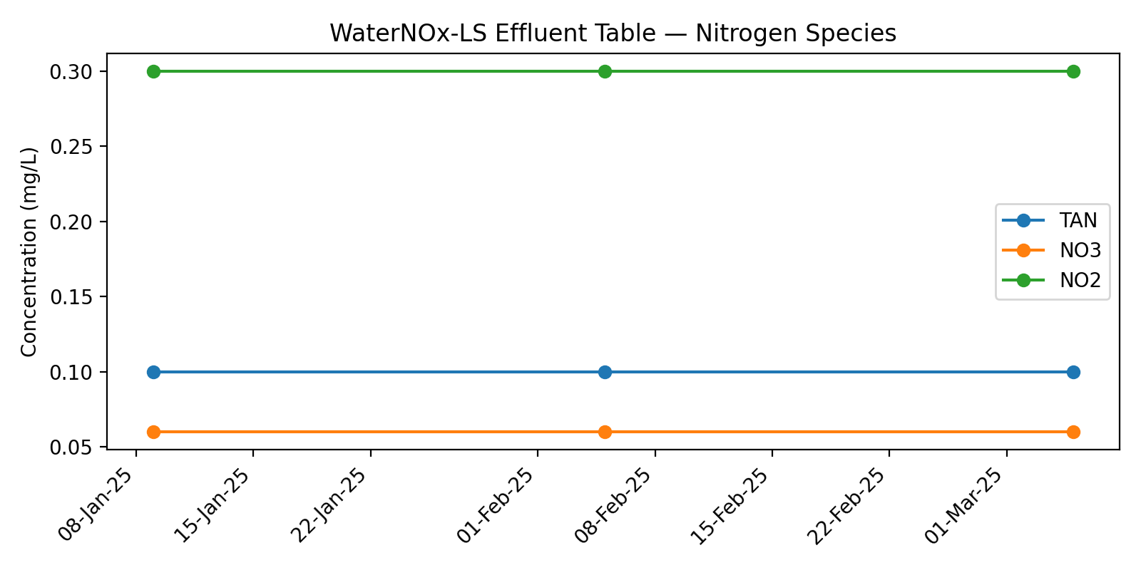

## WaterNOx-S Effluent Table

|  |  |  |  |  |
| --- | --- | --- | --- | --- |
| Date | cBOD5 | TAN | NO3 | NO2 |
| 09-Jan-25 | 89 | 0.2 | 0.06 | 0.3 |
| 05-Feb-25 | 165 | 0.1 | 0.06 | 0.3 |
| 05-Mar-25 | 199 | 0.1 | 0.06 | 0.3 |

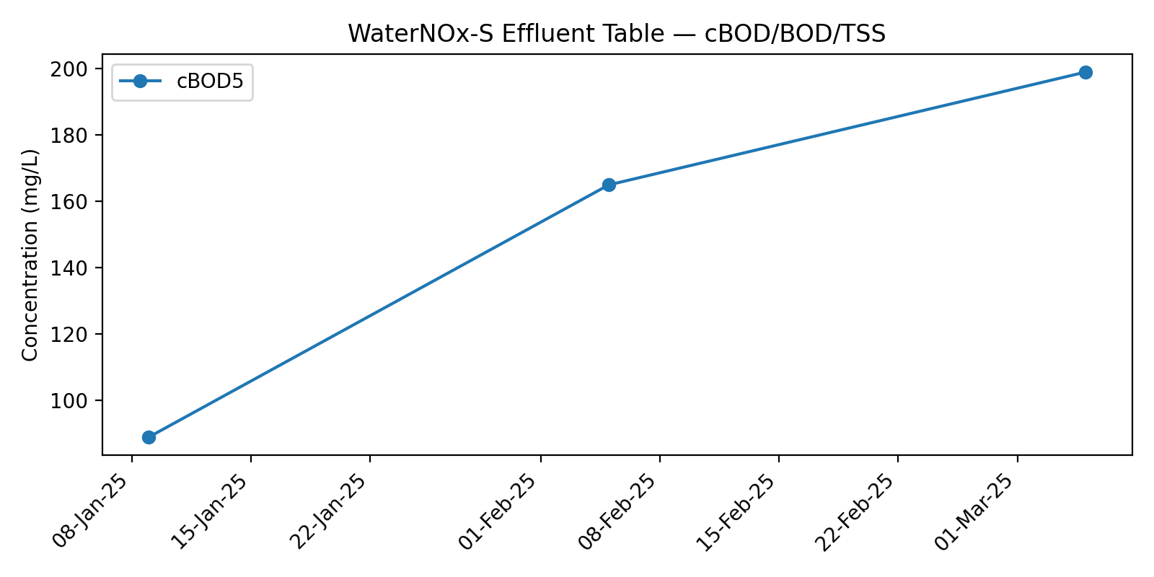

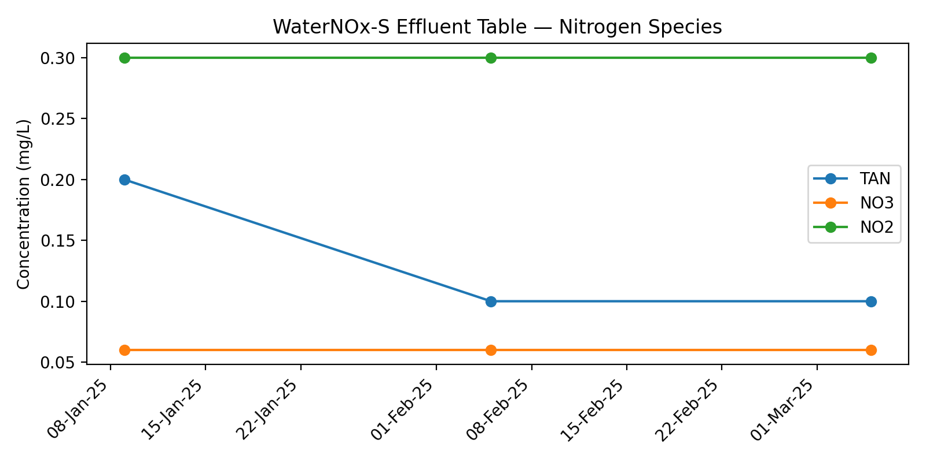

## Final Effluent Table

|  |  |  |  |  |  |  |  |
| --- | --- | --- | --- | --- | --- | --- | --- |
| Date | cBOD5 | TSS | TKN | TAN | NO3 | NO2 | TN |
| 09-Jan-25 | 5 | 3 | 0.9 | 0.1 | 0.06 | 0.3 | 0.16 |
| 21-Jan-25 | 12 | 10 | 0.8 | 0.2 | 0.65 | 0.3 | 0.85 |
| 05-Feb-25 | 12 | 8 | 0.6 | 0.1 | 0.06 | 0.3 | 0.16 |
| 19-Feb-25 | 5 | 2 | 0.8 | 0.1 | 0.14 | 0.3 | 0.24 |
| 05-Mar-25 | 7 | 5 | 0.9 | 0.3 | 0.06 | 0.3 | 0.36 |
| 21-Mar-25 | 18 | 14 | 0.5 | 0.2 | 0.06 | 0.3 | 0.26 |

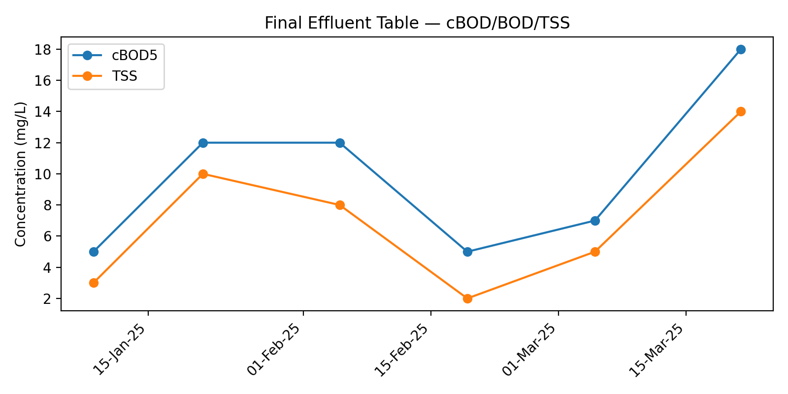

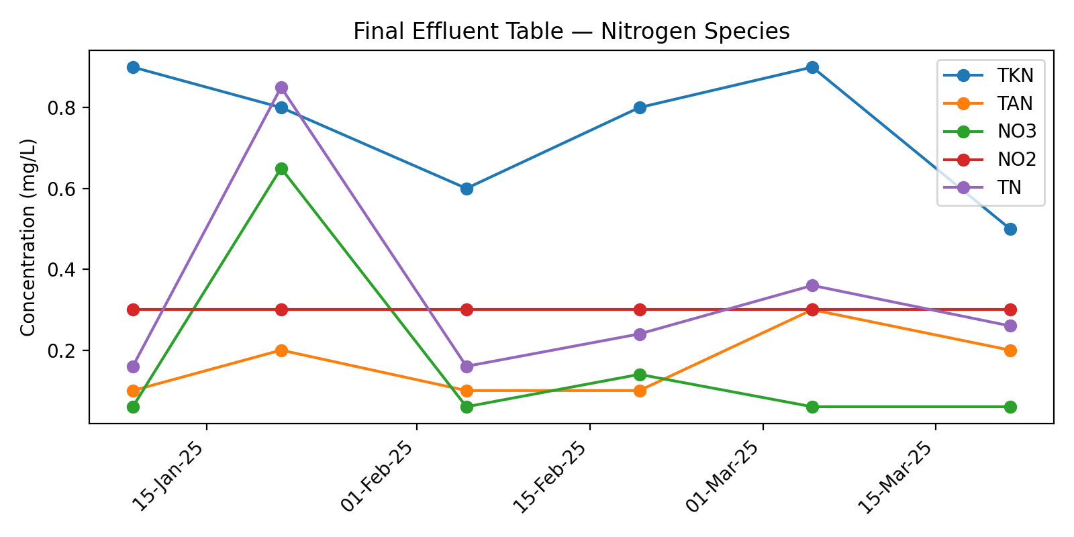

# Appendix B: Flow Data — January 2025

## Jan 25

|  |  |  |  |
| --- | --- | --- | --- |
| Date | Flowmeter 1 Total (L) | Flowmeter 1 (L/day) | Total Daily Flow (L/day) |
| 01-Jan-25 | 4028133 | 12664 | 12664 |
| 02-Jan-25 | 4040589 | 12456 | 12456 |
| 03-Jan-25 | 4052566 | 11977 | 11977 |
| 04-Jan-25 | 4061401 | 8835 | 8835 |
| 05-Jan-25 | 4066697 | 5296 | 5296 |
| 06-Jan-25 | 4073714 | 7017 | 7017 |
| 07-Jan-25 | 4084707 | 10993 | 10993 |
| 08-Jan-25 | 4097014 | 12307 | 12307 |
| 09-Jan-25 | 4110478 | 13464 | 13464 |
| 10-Jan-25 | 4123816 | 13338 | 13338 |
| 11-Jan-25 | 4136761 | 12945 | 12945 |
| 12-Jan-25 | 4138710 | 1949 | 1949 |
| 13-Jan-25 | 4144112 | 5402 | 5402 |
| 14-Jan-25 | 4158092 | 13980 | 13980 |
| 15-Jan-25 | 4170278 | 12186 | 12186 |
| 16-Jan-25 | 4182696 | 12418 | 12418 |
| 17-Jan-25 | 4196109 | 13413 | 13413 |
| 18-Jan-25 | 4208000 | 11891 | 11891 |
| 19-Jan-25 | 4211559 | 3559 | 3559 |
| 20-Jan-25 | 4215439 | 3880 | 3880 |
| 21-Jan-25 | 4228283 | 12844 | 12844 |
| 22-Jan-25 | 4241697 | 13414 | 13414 |
| 23-Jan-25 | 4253355 | 11658 | 11658 |
| 24-Jan-25 | 4265838 | 12483 | 12483 |
| 25-Jan-25 | 4271195 | 5357 | 5357 |
| 26-Jan-25 | 4271196 | 1 | 1 |
| 27-Jan-25 | 4277113 | 5917 | 5917 |
| 28-Jan-25 | 4290490 | 13377 | 13377 |
| 29-Jan-25 | 4303194 | 12704 | 12704 |
| 30-Jan-25 | 4310809 | 7615 | 7615 |
| 31-Jan-25 | 4323546 | 12737 | 12737 |
| Total Flow (L) |  |  | 308077 |
| Average Flow (L/day) |  |  | 9938 |

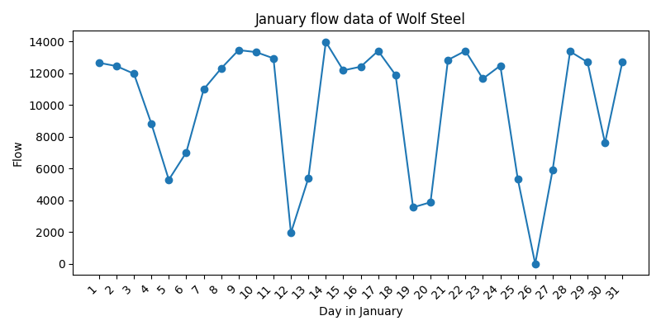

# Appendix C: Site Notes

# Appendix B: Flow Data — February 2025

## Feb 25

|  |  |  |  |
| --- | --- | --- | --- |
| Date | Flowmeter 1 Total (L) | Flowmeter 1 (L/day) | Total Daily Flow (L/day) |
| 01-Feb-25 | 4331766 | 8220 | 8220 |
| 02-Feb-25 | 4331766 | 0 | 0 |
| 03-Feb-25 | 4336825 | 5059 | 5059 |
| 04-Feb-25 | 4349596 | 12771 | 12771 |
| 05-Feb-25 | 4363201 | 13605 | 13605 |
| 06-Feb-25 | 4371109 | 7908 | 7908 |
| 07-Feb-25 | 4383209 | 12100 | 12100 |
| 08-Feb-25 | 4386431 | 3222 | 3222 |
| 09-Feb-25 | 4386431 | 0 | 0 |
| 10-Feb-25 | 4392937 | 6506 | 6506 |
| 11-Feb-25 | 4404781 | 11844 | 11844 |
| 12-Feb-25 | 4412368 | 7587 | 7587 |
| 13-Feb-25 | 4424829 | 12461 | 12461 |
| 14-Feb-25 | 4431026 | 6197 | 6197 |
| 15-Feb-25 | 4437763 | 6737 | 6737 |
| 16-Feb-25 | 4437763 | 0 | 0 |
| 17-Feb-25 | 4437763 | 0 | 0 |
| 18-Feb-25 | 4446764 | 9001 | 9001 |
| 19-Feb-25 | 4456602 | 9838 | 9838 |
| 20-Feb-25 | 4469563 | 12961 | 12961 |
| 21-Feb-25 | 4477890 | 8327 | 8327 |
| 22-Feb-25 | 4487956 | 10066 | 10066 |
| 23-Feb-25 | 4487956 | 0 | 0 |
| 24-Feb-25 | 4493111 | 5155 | 5155 |
| 25-Feb-25 | 4506266 | 13155 | 13155 |
| 26-Feb-25 | 4519566 | 13300 | 13300 |
| 27-Feb-25 | 4533296 | 13730 | 13730 |
| 28-Feb-25 | 4546456 | 13160 | 13160 |
| Total Flow (L) |  |  | 222910 |
| Average Flow (L/day) |  |  | 7961 |

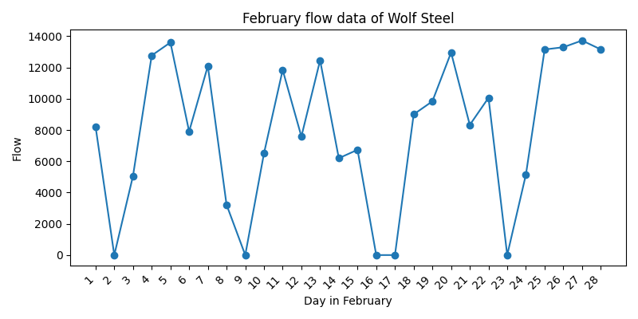

# Appendix C: Site Notes

# Appendix B: Flow Data — March 2025

## Mar 25

|  |  |  |  |
| --- | --- | --- | --- |
| Date | Flowmeter 1 Total (L) | Flowmeter 1 (L/day) | Total Daily Flow (L/day) |
| 01-Mar-25 | 4559214 | 12758 | 12758 |
| 02-Mar-25 | 4559214 | 0 | 0 |
| 03-Mar-25 | 4567514 | 8300 | 8300 |
| 04-Mar-25 | 4579992 | 12478 | 12478 |
| 05-Mar-25 | 4593955 | 13963 | 13963 |
| 06-Mar-25 | 4606515 | 12560 | 12560 |
| 07-Mar-25 | 4619522 | 13007 | 13007 |
| 08-Mar-25 | 4632810 | 13288 | 13288 |
| 09-Mar-25 | 4644814 | 12004 | 12004 |
| 10-Mar-25 | 4657101 | 12287 | 12287 |
| 11-Mar-25 | 4668912 | 11811 | 11811 |
| 12-Mar-25 | 4680460 | 11548 | 11548 |
| 13-Mar-25 | 4693602 | 13142 | 13142 |
| 14-Mar-25 | 4705175 | 11573 | 11573 |
| 15-Mar-25 | 4719052 | 13877 | 13877 |
| 16-Mar-25 | 4736744 | 17692 | 17692 |
| 17-Mar-25 | 4754540 | 17796 | 17796 |
| 18-Mar-25 | 4771948 | 17408 | 17408 |
| 19-Mar-25 | 4787667 | 15719 | 15719 |
| 20-Mar-25 | 4804179 | 16512 | 16512 |
| 21-Mar-25 | 4820834 | 16655 | 16655 |
| 22-Mar-25 | 4833796 | 12962 | 12962 |
| 23-Mar-25 | 4847106 | 13310 | 13310 |
| 24-Mar-25 | 4859749 | 12643 | 12643 |
| 25-Mar-25 | 4871911 | 12162 | 12162 |
| 26-Mar-25 | 4884819 | 12908 | 12908 |
| 27-Mar-25 | 4897850 | 13031 | 13031 |
| 28-Mar-25 | 4909842 | 11992 | 11992 |
| 29-Mar-25 | 4918746 | 8904 | 8904 |
| 30-Mar-25 | - |  | 4404 |
| 31-Mar-25 | - | - | 4404 |
| Total Flow (L) |  |  | 381098 |
| Average Flow (L/day) |  |  | 12293 |

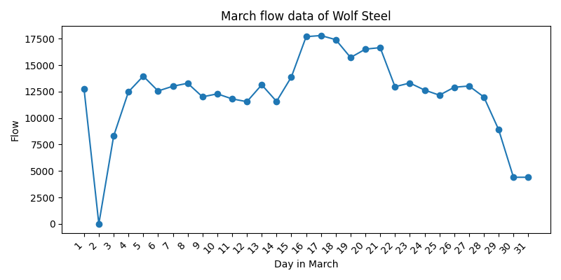

# Appendix C: Site Notes